

# **PROJECT REPORT**

## 2022-23

## CSE

## ON

**E-Commerce Website**

**SUBMITTED IN PARTIAL FULFILLMENT OF THE DEGREE**

## OF

# **INT. B.E M.E(CSE)**

**Under the Guidance of:** **Submitted By:**

**Name:** Dr Hakam Singh **Udit Sharma- 2111985054**

**Designation:** Assistant Professor  **Sourav Kumar- 2111985060**

**Department: CSE Vishal- 2111985057**

**Vaibhav Sharma- 2111985055**

Chitkara University, Himachal Pradesh, India.

**INDEX**

|  |  |
| --- | --- |
| **CHAPTER** | **PAGE NO.** |
| 1. Introduction | **2** |
| 1. Requirement Analysis | **3** |
| * Need & Objectives of Proposed System | **3-4** |
| * System Analysis | **5** |
| * Feasibility Study | **6** |
| 1. Design | **7-13** |
| 1. Coding | **14-21** |
| 1. Testing | **21-31** |
| 1. Implementation | **31-33** |
| 1. Conclusion and Future Scope | **33-34** |
| 1. Bibliography | **34-35** |

**INTRODUCTION**

**Online Shopping** is designed to provide a seamless shopping experience for our customers, with a wide range of product, easy navigation, and multiple payment options. We believe that our platform offers a unique and convenient way to shop online. This project consists of the development of a contributory web application. It is an all in one website where users can buy fashion accessories and can order a variety of products online. We provide a wide range of products which include denim jeans, jackets, sportswear, shoes, sneakers, electronic items, camera accessories and many more. We also provide special discounts on special days. We use multiple languages for creating this website like CSS, JS, html and bootstrap.

**Need:**

Many websites have inconsistent pricing and shipping policies, which can lead to confusion and mistrust. Additionally, consumers often struggle to find products that meet their specific needs and preferences.

**Problem:**

* One of the biggest problems is the lack of transparency and reliability in pricing and shipping policies.
* Many online retailers have inconsistent policies, which can cause confusion and mistrust among consumers.
* Another problem is the difficulty of finding products that meet specific needs and preferences.
* Many online retailers have limited product offerings and a lack of customization options.
* Designers need to create a user interface that is easy to use and the website is compatible for every device.
* Online shopping websites need to load quickly and offer a smooth user experience.

**Solution:**

* Our website will offer a seamless and enjoyable online shopping experience for our target audience.
* We will provide clear and consistent pricing and shipping policies to build trust with our customers.
* Our website will offer a wide range of products and customization options to meet the diverse needs and preferences of our target audience.
* Our website will be designed with a user-friendly interface to make online shopping easy and stress-free.

**Objectives:**

Our Main Objective is to increase online sales by 30% in the first year of launch, by providing a user-friendly interface. Expand the product range by adding at least 100 new products every month to attract new customers and increase revenue. Increase customer engagement by offering personalized recommendations based on customer behavior and purchase history. Improve website search functionality to enable customers to easily find products.

The outcome of an online shopping website can include:

* A user-friendly online shopping website can improve customer satisfaction by providing an easy and convenient shopping experience, along with excellent customer service and support.
* A successful online shopping website can provide businesses with a competitive advantage over competitors by offering unique features and services that attract and retain customers.
* The data collected through an online shopping website can provide valuable insights into customer behaviour, preferences, and trends, allowing businesses to make informed decisions and better understand their customers.
* The website should be optimized for search engines to improve its visibility in search results and drive organic traffic to the website.
* An effective online shopping website can lead to increased sales and revenue by providing customers with a convenient way to purchase products and services.
* An online shopping website can provide greater flexibility for businesses to adapt to changing market conditions
* Network independent. The system should be able to operate over any IP-based wireless/mobile network (e.g., GPRS, UMTS, Wi-Fi)

**REQUIREMENT ANALYSIS**

**Software:**

* Operating System: Window 7, Window 8, Window 10, Window 11
* Browser (Chrome, Firefox, Microsoft edge)
* Visual studio 2020
* HTML

**Hardware:**

* Minimum Hardware Requirement that can support Chrome, Firefox, Microsoft edge.
* 120 MHz Processor
* 512 MB RAM

**Database:**

* SQL Server

SYSTEM ANALYSIS

System analysis is a crucial step in the development of an online shopping website project. It involves the examination of the current business processes, identifying potential improvements, and designing a new system that meets the requirements and objectives of the project.

The first step in system analysis is to identify stakeholders who will be impacted by the new system.

The next step is to gather and document requirements for the new system.

The current system should be analysed to identify strengths and weaknesses, and to identify areas for improvement.

**SYSTEM STUDY AND PROBLEM DEFINATION:**

**1) SYSTEM ANALYSIS**.

It consists of the following steps

* 1. Feasibility study.
  2. Information gathering.
  3. Making algorithms and flowcharts.

1. **SYSTEM DESIGN AND PROGRAMMING.**
2. **IMPLEMENTATION AND DOCUMENTATION.**

System study and problem definition is the first stage in the development of an online shopping website project. This stage involves a detailed analysis of the current business processes and identifying problems or inefficiencies that the new system should address. Here are some key elements of the system study and problem definition stage:

1. **Identify Business Processes:** The first step is to identify the current business processes that the new system will be designed to support.
2. **Gather Data:** Data should be gathered about the current processes, including information on the number of transactions, customer behaviour, and inventory levels.
3. **Identify Problems**: Based on the data collected, problems and inefficiencies in the current system should be identified.
4. **Define System Scope:** The scope of the new system should be defined based on the objectives and constraints identified.

**FEASIBILITY STUDY**

Feasibility study is a critical stage in the development of an online shopping website project. It involves evaluating the technical, economic, and operational feasibility of the project to determine whether it is viable and worth pursuing. Here are some key elements of the feasibility study stage:

1. **Technical Feasibility:** The technical feasibility of the project should be evaluated by assessing the availability of the required technology and expertise to design, develop, and deploy the new system.
2. **Operational Feasibility:** The operational feasibility of the project should be evaluated by assessing the impact of the new system on the business processes and the ability of the organization to adopt and use the new system.
3. **Economic Feasibility:** The economic feasibility of the project should be evaluated by analysing the costs and benefits associated with the new system. This includes identifying the costs of developing and deploying the new system, as well as the potential benefits, such as increased revenue and cost savings.
4. **Market Feasibility**: The market feasibility of the project should be evaluated by analysing the demand for the products or services offered by the online shopping website, as well as the competition in the market.
5. **Legal Feasibility:** The legal feasibility of the project should be evaluated by identifying any legal or regulatory requirements that must be met to develop and deploy the new system, such as data protection laws or privacy regulations.
6. **Risk Analysis:** A risk analysis should be conducted to identify potential risks and issues that may impact the success of the project, such as technical failures, delays in development, or customer dissatisfaction.
7. **Recommendation:** Based on the findings of the feasibility study, a recommendation should be made as to whether the project is viable and worth pursuing.

**DESIGN**

Design of an online shopping website involves creating a user-friendly and visually appealing interface that facilitates easy navigation and provides a seamless shopping experience to customers.

Here are some key elements of the design stage:

1. **User Interface Design:** The user interface of the online shopping website should be designed to be simple, intuitive, and easy to use. The website should have a consistent layout and design, with clear and concise menus and navigation options.
2. **Homepage Design:** The homepage of the website should be designed to grab the attention of visitors and provide an overview of the products and services offered.
3. **Shopping Cart Design:** The shopping cart should be designed to be easily accessible and simple to use.
4. **Checkout Design:** The checkout process should be designed to be simple and streamlined, with clear instructions and guidance for customers.
5. **Accessibility:** The website should be designed to be accessible to users

**DATAFLOW DIAGRAM:**

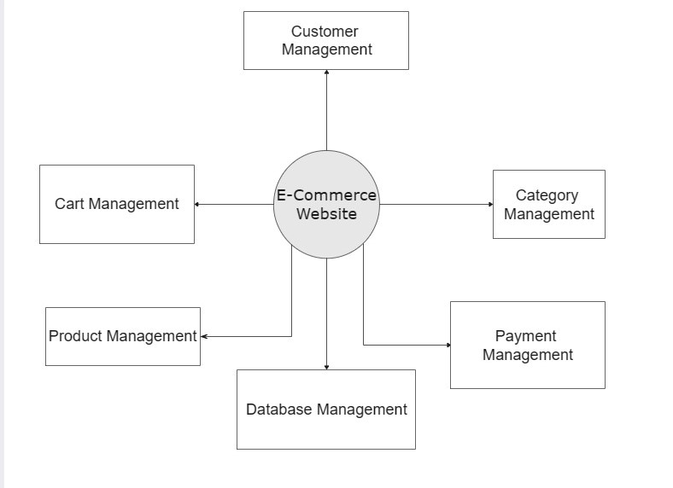

O-level DFD

**CONTINUED:**

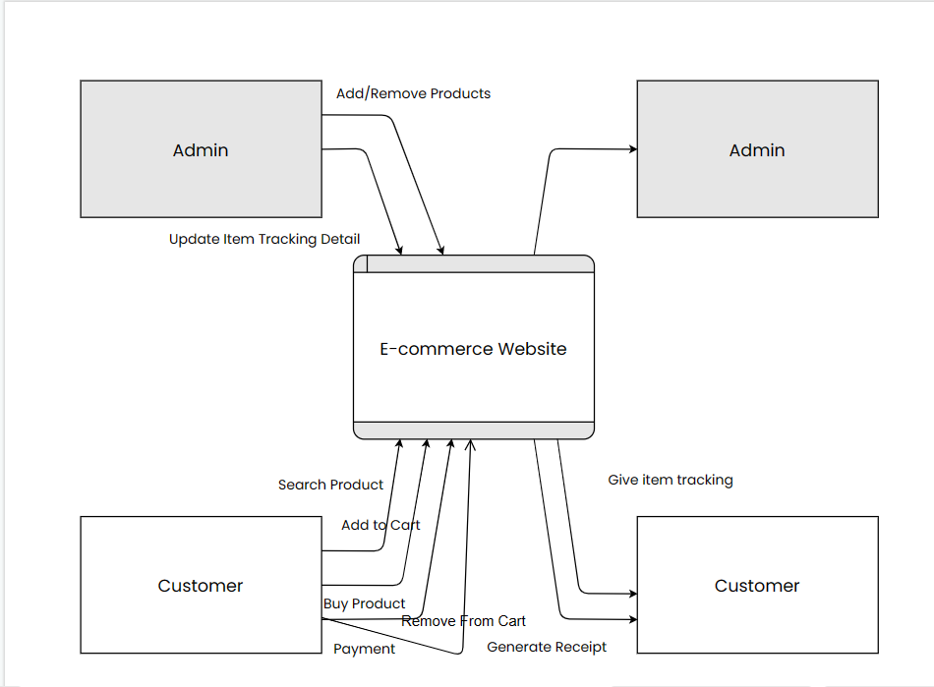

1-Level DFD

**CONTINUED:**

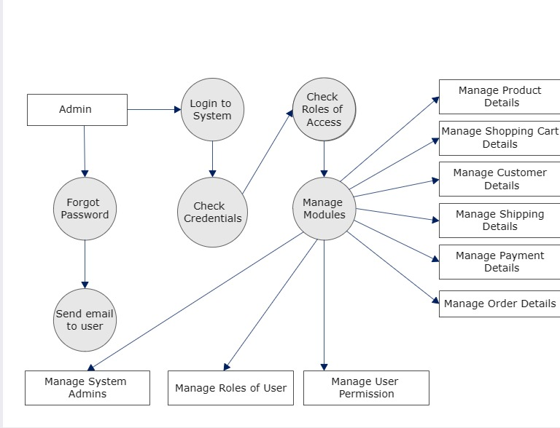

2-Level DFD

**USE CASE DIAGRAM:**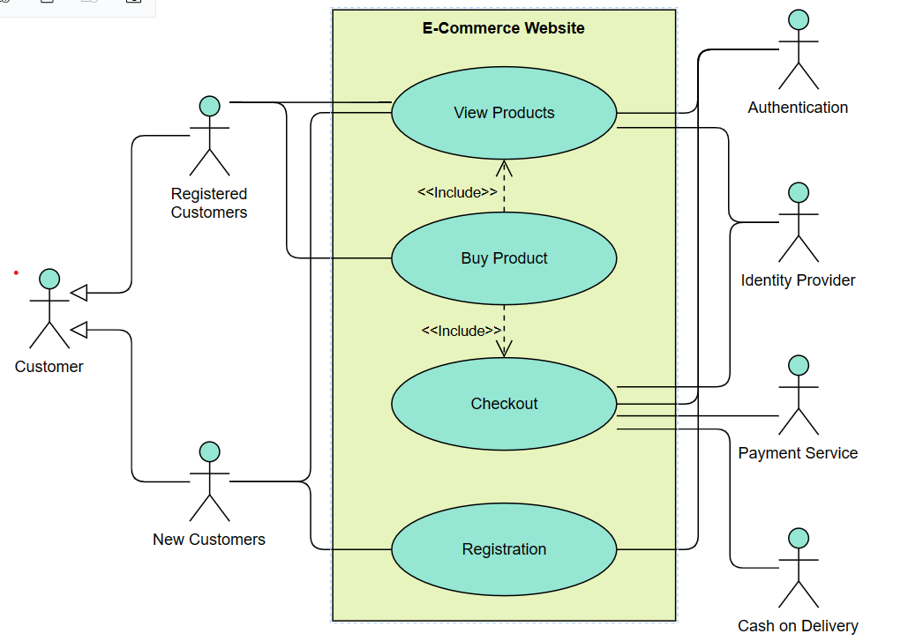

Use Case diagram

**MASTER PAGE DESIGN:**

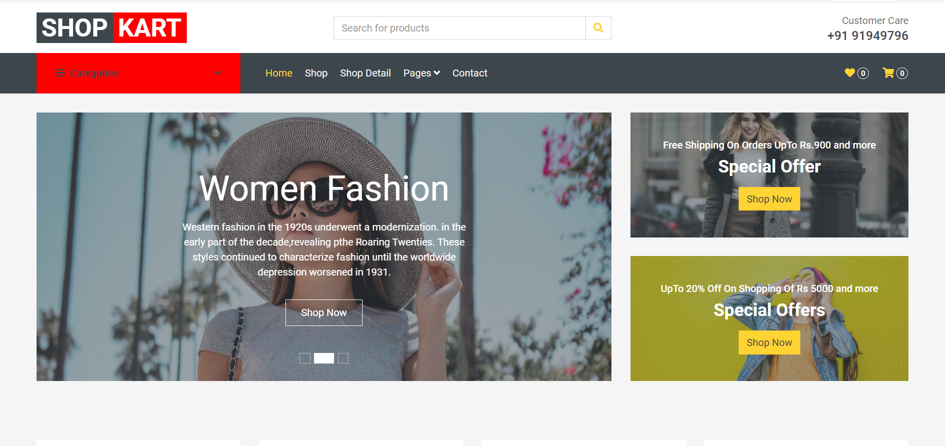

Homepage

**SHOPPING CART PAGE:**

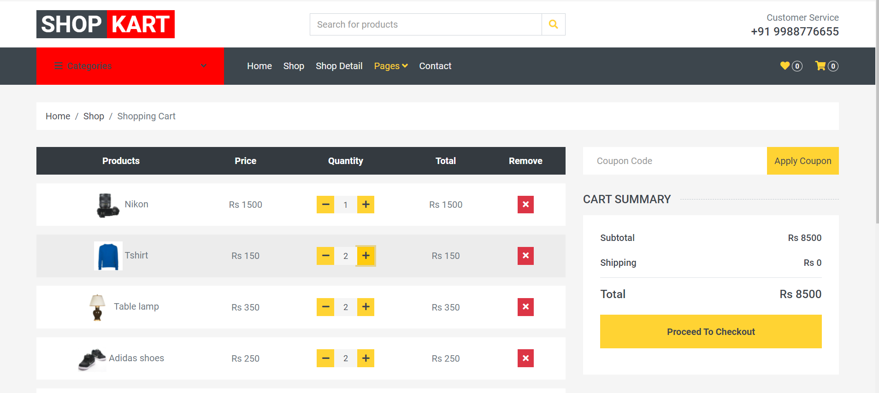

Shopping Cart

**CHECKOUT PAGE:**

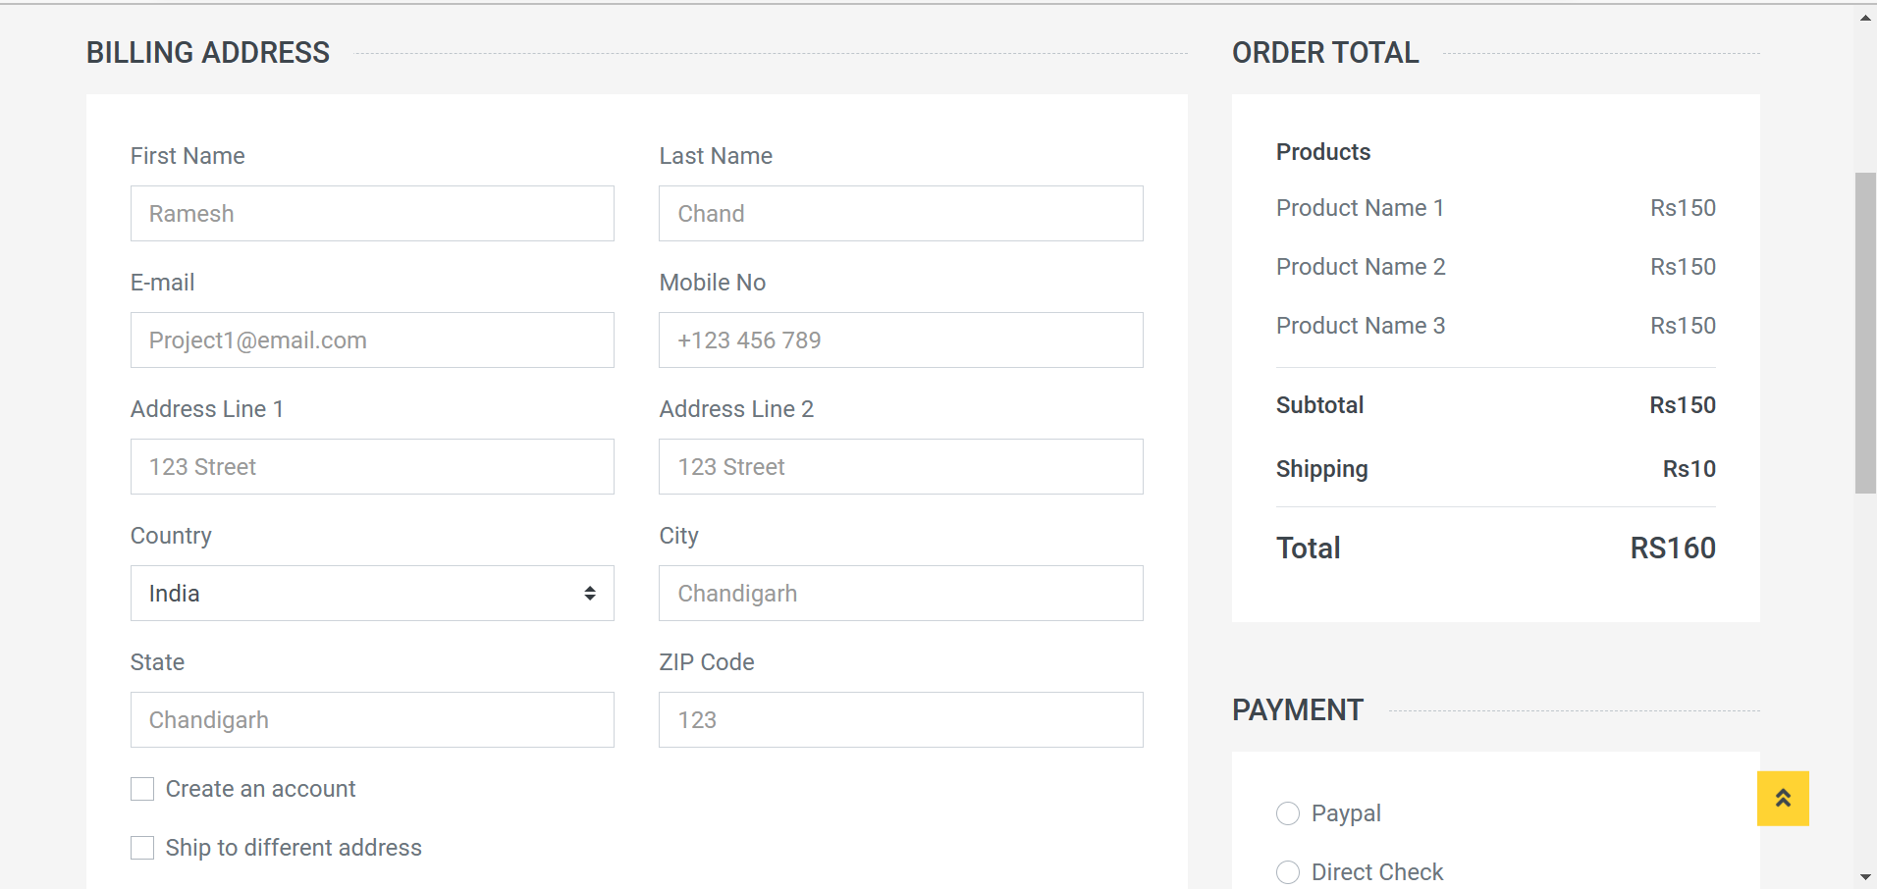

Checkout Page

**LOGIN PAGE:**



Login Page

**CODING – MASTERPAGE:**

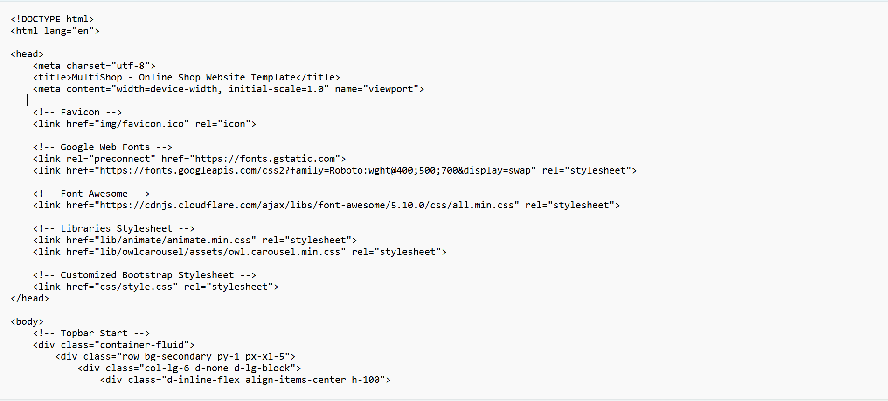

Master Page Coding

**CHECKOUT PAGE:**

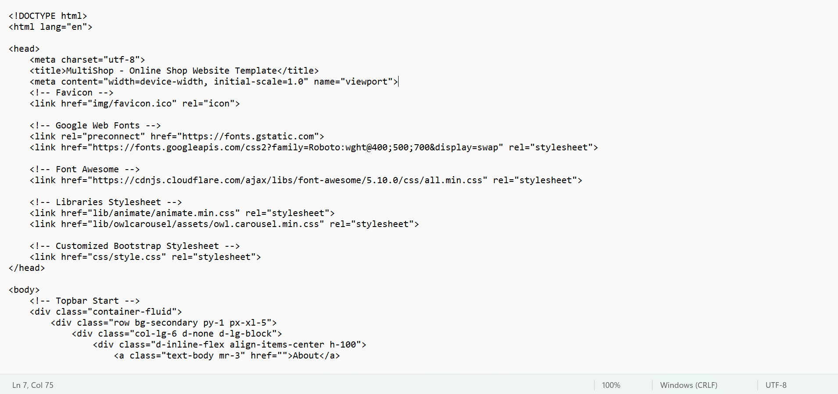

CHECKOUT PAGE

**CART PAGE:**



CART PAGE

**TESTING**

The purpose of system testing is to identify and correct errors in the candidate system. Testing is an important element of software quality assurance and represents the ultimate review of specification, design and coding. The increasing visibility of the software as a system element and the cost associated with a software failure are motivated forces for well planned, through testing.

**Unit Testing:**

Unit testing is a type of testing that focuses on verifying the behaviour of individual units or components of software. In the context of an online shopping website project, unit testing can provide a number of benefits, including:

1. **Catching Bugs Early:** By testing individual components of the website as they are developed, unit testing can help identify bugs and errors early in the development process, before they become larger problems.

2. **Ensuring Functionality:** Unit testing can help ensure that each component of the website functions as intended, both in isolation and as part of the larger system.

3. **Improving Code Quality:** Unit testing can encourage developers to write more modular, maintainable code, as they are forced to consider each component in isolation.

4. **Facilitating Refactoring:** When code needs to be refactored or modified, unit tests can help ensure that the changes do not introduce new bugs or break existing functionality.

5. **Enabling Continuous Integration:** By automating unit tests and integrating them into a continuous integration pipeline, developers can ensure that each change to the codebase does not break existing functionality.

**System Testing:**

System testing is a type of testing that evaluates the complete system as a whole, rather than individual components. In the context of an online shopping website project, system testing can provide several benefits, including:

1. **Verifying End-to-End Functionality:** System testing can help ensure that all components of the website are integrated correctly and functioning as intended, from the user interface to the backend database.

2. **Identifying Defects and Bugs:** By testing the website in a realistic, production-like environment, system testing can help identify defects and bugs that may have been missed during individual unit testing or integration testing.

3. **Ensuring Security and Compliance:** System testing can help ensure that the website meets security and compliance requirements, such as ensuring that user data is protected and that the website complies with relevant laws and regulations.

4. **Evaluating Performance and Scalability:** System testing can help evaluate the website's performance under heavy loads, such as during peak shopping periods, and identify any scalability issues.

**TESTING:**

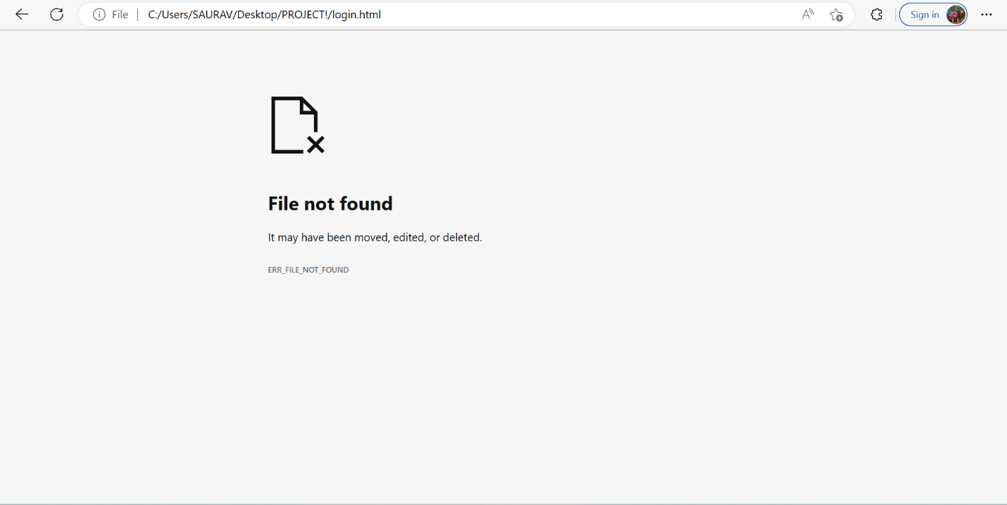

After Configuring the page was working



After testing page was working

**Function Testing:**

Function testing, also known as functional testing, is a type of testing that evaluates the functionality of a system or application. In the context of a shopping website project, function testing can provide several benefits, including:

**1. Verifying User Scenarios:** Function testing can help ensure that the website functions as intended from a user's perspective, such as adding items to a shopping cart, applying discounts or coupons, and completing a purchase.

**2. Identifying Defects and Bugs:** By testing specific functions of the website, function testing can help identify defects and bugs that may have been missed during other types of testing.

**3. Ensuring Compatibility:** Function testing can help ensure that the website functions correctly across different devices, browsers, and operating systems.

**4. Improving Usability:** By testing specific functions of the website, function testing can help identify areas where the user experience can be improved, such as simplifying checkout or making navigation more intuitive.

**5. Ensuring Integration:** Function testing can help ensure that different parts of the website are integrated correctly and functioning as intended, such as integrating payment gateways and shipping providers.

**Objectives of Testing:**

1. Identifying defects and bugs in the system.
2. Ensuring that the system meets functional and non-functional requirements.
3. Verifying that the system works correctly and as intended.
4. Ensuring that the system is reliable and performs well.
5. Identifying and mitigating risks associated with the system.
6. Ensuring that the system is secure and protects sensitive data.
7. Ensuring that the system is usable and provides a positive user experience.
8. Ensuring that the system is maintainable and can be updated or modified as nee

**IMPLEMENTATION AND MAINTENANCE**

The implementation and maintenance of an online shopping website can be broken down into several key steps:

1. **Planning:** The first step is to plan the website's design, functionality, and features. This includes deciding on the layout, colour scheme, and user interface.
2. **Development:** Once the planning is complete, the website can be developed. This involves coding the website and testing the website to ensure it functions properly.
3. **Launch:** After development is complete, the website can be launched. This involves making the website live and accessible to the public.
4. **Maintenance:** Maintaining the website is essential to ensure it continues to function properly and remains up-to-date.
5. **Marketing:** Finally, marketing the website is essential to attract customers and generate sales.

**Implementation Tools:**

There are several tools that can be used for implementing an online shopping website. Some of the popular ones include:

* Content Management Systems (CMS)
* Web Development Frameworks
* Web Hosting Services

**SOFTWARE MAINTENANCE**

Software maintenance is the process of modifying and updating software after it has been deployed to fix bugs, improve performance, or add new features. It is an essential part of the software development life cycle and is necessary to ensure the software remains usable and relevant over time.

There are four main types of software maintenance:

1. **Corrective Maintenance:** This type of maintenance is focused on fixing bugs and errors that were not discovered during the development process.

2. **Adaptive Maintenance:** Adaptive maintenance involves modifying the software to accommodate changes in the environment or user requirements.

3**. Perfective Maintenance:** This type of maintenance is focused on improving the performance, usability, or efficiency of the software.

4. **Preventive Maintenance:** Preventive maintenance is focused on proactively identifying and addressing potential issues before they become major problems. This can include regular updates to the software, monitoring for potential issues, and conducting regular maintenance activities to prevent problems from occurring.

**CONCLUSION AND FUTURE SCOPE**

**CONCLUSION:** In conclusion, we have designed and developed a comprehensive shopping website that aims to provide a convenient and enjoyable shopping experience to our users. We have implemented various features such as user-friendly navigation,

advanced search functionality, detailed product descriptions, and secure payment options to ensure that our customers can easily find and purchase the products they need.Overall, our shopping website is designed to meet the needs and expectations of modern-day shoppers, and we are confident that it will be a valuable addition to the online shopping landscape. We look forward to hearing feedback from our users and making continuous improvements to enhance their shopping experience.

**FUTURE SCOPE:**

The future scope of an online shopping project is vast and constantly evolving as technology advances and consumer behaviour changes. Here are some potential areas of development for the future:

* Implementing personalized product recommendations based on customer search history and behavior to enhance the shopping experience
* Incorporating augmented reality and virtual reality technology to allow customers to visualize products before purchase
* Developing a mobile application for the website to increase accessibility and convenience for customers on-the-go
* Implementing chatbots or virtual assistants to provide 24/7 customer support and assistance with inquiries and orders

**BIBLIOGRAPHY**

**Books:**

* Web Design with HTML, CSS, JavaScript and jQuery Set by Jon Duckett (2014)
* Responsive Web Design by Ethan Marcotte (2011)
* Designing with Web Standards by Jeffrey Zeldman (2003)
* The Principles of Beautiful Web Design by Jason Beaird (2014)

**Websites:**

* Wikipedia for various diagrams & testing methods <http://www.geekforgeeks.org/>
* Cool text for Images and Buttons <http://pinterest.com/>
* Smart Draw for drawing all the Diagrams used in this report. <http://www.creately.com/>